- The graph below is the derivative of a function, f, whose domain is the set of all real numbers and is continuous everywhere. Determine the x-values for the relative extreme for f.
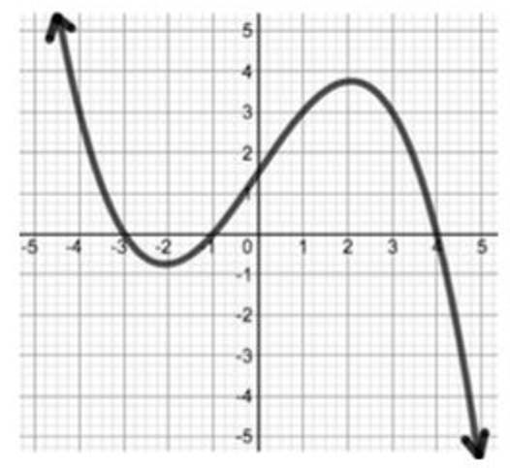
- Find the exact global maximum and minimum values (y-values) of the function f(t)=t/(1+t^2) on the interval [-3,3].
- Find the global maximum and minimum (y-values) of the function f(x)=x+sin(2x) on the interval [0,pi].
- Identify the intervals where f(x)=1/4*x^4+1/3*x^3-8x^2-16x is increasing and decreasing on the interval [-4,4]. Then determine the local extrema of f(x). Lastly determine the absolute extrema of f(x).
Answer as follows-
F(x) is increasing:
F(x) is decreasing:
Local Minimum:
Local Maximum:
Absolute Minimum:
Absolute Maximum:
- Using the second derivative test determine the local extrema of f(x)=1.3*x^3+3/2*x^2-18x+26.
- Find the value(s) of c that satisfy the Mean Value Theorem for f(x)=sqrt(x+4) in the interval [-4,6] if possible.
Answer as follows:
The function is (continuous or Not continuous) on the interval [-4,6]. The function is (differentiable/not differentiable) on the interval (-4,6). What are the values of c; if any?
- Find the value(s) of c that satisfy the Mean Value Theorem for f(x)=(x^2+3x-40)/(x+4) on the interval [0,5].
Answer as follows:
F(x) is (continuous or Not continuous) on the interval [0,5]. The function is (differentiable/not differentiable) on the interval (0,5). What are the values of c; if any?
- The graph below is the derivative of a function, g, whose domain is the set of all real numbers and is continuous everywhere. Determine the intervals where g is concave up. Choose all that apply.
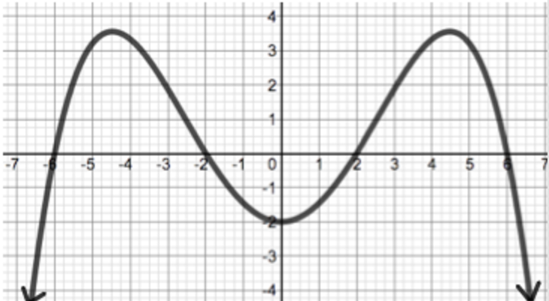
Possible answers:
(-infinity, -4.5)
(0,4.5)
(-6,-2)
(-2,2)
- Identify the intervals of concavity and the point inflection for f(x)=(7)sqrt(x^5).
Answer as follows-
Inflection point(s):
Concave Up:
Concave Down:
- Identify the intervals of concavity and the points of inflection for f(x)=1/2*x^4
-4x^3+9x^2.

